NEUROSPIN is looking for a DIRECTOR for its MEG CENTER

Join a dynamic group that pushes the limits of human magneto-encephalography and brain decoding!

Applications are invited for a tenure-track position as director of the Magneto-Encephalography Center at NeuroSpin in Saclay, near Paris, France, directed by Stanislas Dehaene.

The call is for a permanent position as Research Engineer at INSERM (French equivalent of NIH). Tenure will be evaluated within a year of the initial contract. Salary is commensurate with experience.

Profile: The successful candidate will have a competitive record of publications and a demonstrated expertise in MEG research or closely related fields. The successful candidate will manage the NeuroSpin MEG center, ensure the availability of the best tools for NeuroSpin research teams and collaborators, and develop new MEG-based research in cognitive neuroscience, in tight collaboration with Stanislas Dehaene, Christophe Pallier, Ghislaine Dehaene-Lambertz, Virginie van Wassenhove and other researchers at NeuroSpin.

Eligible qualifications for this position include:
- Ph.D. in Physics, Engineering, Cognitive neuroscience, or related discipline
- Thorough knowledge of the technical, theoretical and practical principles of M/EEG
- Fluent knowledge in computer programming (languages: python, Matlab, shell scripting, C++)
- Knowledge of cognitive neuroscience
Knowledge of the French language is not required, but would be a bonus.
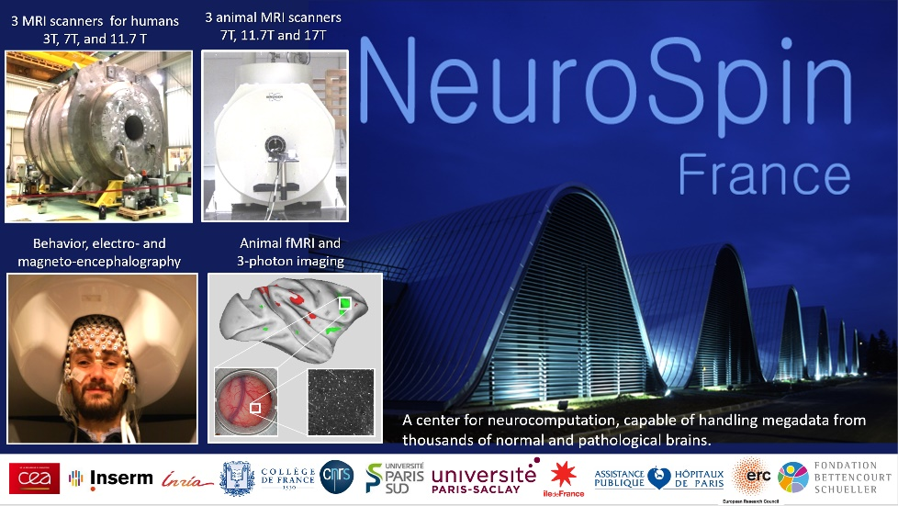
NeuroSpin is France’s advanced brain-imaging center – a building entirely dedicated to the understanding of the human brain and the development of neuroscience technologies. Five laboratories currently share their expertise on site and provide a stimulating research environment. NeuroSpin hosts 8 state-of-the-art neuroimaging systems including three human MRIs (3T, 7T, and soon a world-record 11.7 Tesla), three animal MRIs (7T, 11.7T and 17.T), an MEG system, and a 3-photon imaging system. The MEG is a 306-channel system (Neuromag/Elekta) typically paired with EEG (native + EGI) and eye-tracking (Eyelink 1000 SR Research).
NeuroSpin teams develop advanced post-processing tools for structural image processing (BrainVisa), fMRI data analysis (Nipy, Nilearn), diffusion imaging (Connectomist), and M/EEG analysis (MNE Python). A 150-terabyte data archiving system, a large local computer cluster and access to the new CEA supercomputer are available. Neurospin’s environment also benefits from the new NeuroPSI building, dedicated to fundamental neuroscience and opening in 2019.
Submit a letter detailing your current research interests, a curriculum vitae, and two letters of recommendation (or the appropriate contact information) to giovanna.santoro@cea.fr with “Meg candidate” in the headline. Please apply before September 1st, 2019, for a start date in the Fall 2019.

